Lineage Logistics – Consulting Project

By: Alejandro Garcia

**OVERVIEW**

There are multiple choices one may make when choosing which electrical rate to purchase on a daily basis. Every day, hourly rates are published by Mira Loma CAISO for the next day. One may choose to either select those day-ahead rates (DAM) or to elect rates that are determined every 5 minutes (RTM5) or rates that are determined every 15 minutes (RTM15). The objective is to forecast RTM5 and RTM15 daily costs such that cost is minimized by the optimal rate selection.

# GOALS

1. Formalizing/cleaning up the existing API code and adding the functionality to quickly obtain future Day Ahead, 15-min Real Time and 5-min Real Time energy rates
2. Running analytics on the data and other external sources that you may find to help predict when 15 min or 5 min price spikes may occur relative to the locked-in day ahead rate.

# API summary of changes

* The API retrieval code was edited to ensure that every time this code was run, that we pulled the most recent data.
* The current date is being chopped off so that it doesn’t skew the data or forecasts.
* Various bug fixes.

# Analysis Overview

Overall, the analysis consists of 5 steps:

1. Roll up 5 minute, 15 minute, or Day-Ahead hourly rates up to the daily level. The logic behind rolling up the data to the daily level is that we are looking to make forecasts and decisions on a daily basis.
2. Compute daily costs considering constant usage across time periods. I assumed 1 MW of usage per hour. When looking at this time series, I see a decent amount of spikes but also notice that 5 min RTM and 15 min RTM are both pretty non-spikey on the daily level. I

think there is clearly some annual seasonality but also seems to be smaller fluctuations that seem to be on a weekly level. It also seems to be the case that RTM5/RTM15 were the best choices many more times than the Day-Ahead prices.

|  |  |
| --- | --- |
| RTM5 | 291 |
| RTM15 | 106 |
| DAM | 88 |

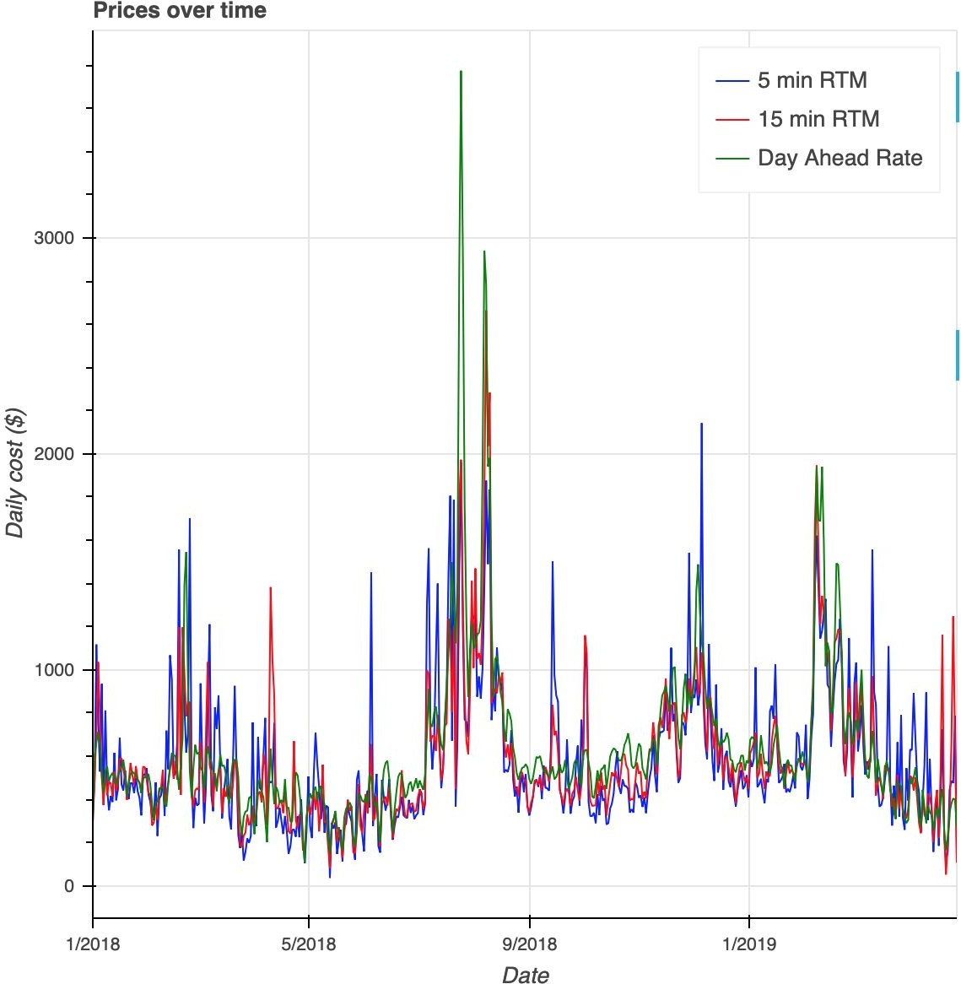

1. Examine the time series and perform transformations to create stationary data. You want to remove seasonality and trends before performing an ARIMA analysis. I performed this for each of the time series: DAM, RTM5, and RTM15. The stationarity tests are performed in by calling the function **test_stationarity**. In doing this analysis, I noticed that all three models performed when subtracting the current daily value from the daily value 7 days ago. This made sense to me because it makes sense that Monday demand last week is similar to demand on a Monday this week.
2. Build the time series models. The models that I built were ARIMA (Autoregressive Integrated Moving Average) and I chose the autocorrelation factors automatically via the function **correlation_funcs**. Once that was complete for each time series, I then fit the

model and visually examined model fit. It was a little hard to see how well the model fit worked.

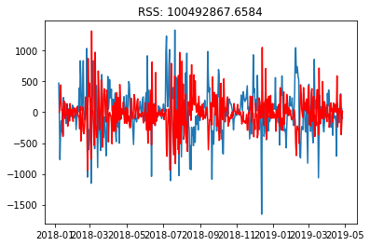

1. Forecast the DAM, RTM5, and RTM15 time series for 7 days. This is a two step process in which we forecast 7 periods ahead and then add this forecast amount to the 7 day lagged actual cost value